

American International University-Bangladesh (AIUB)
Department of Computer Science Faculty of Science & Technology (FST)
PROJECT TITLE
Society Problem Reporter and Analyzer
Submitted By Group 7
Semester-->Summer-25-26 |  | Section:T
SL | Student Name | Student ID
29 | 24-58655-2 | Sheikh Ahnaful Islam
31 | 24-58796-2 | Ayon Chowdhury
22 | 24-58220-2 | MD. Mezbah-Ul-Hossain Rahat
4 | 23-53306-3 | Md Rashed Musharof
3 | 23-52565-2 | Sabit Haan

1 . Project Proposal
1.1 Background to the Problem
Urban and semi-urban communities across Bangladesh deal with a wide range of recurring infrastructural and civic problems on a daily basis: cracked and waterlogged roads, choked drainage lines, non-functioning street lamps, uncollected waste, and damaged footpaths, among others, all of which directly affect public safety, health, and daily mobility. Municipal bodies such as City Corporations, Pourashavas, and Union Parishads are formally responsible for addressing these issues, but the channels through which citizens can bring problems to their attention remain fragmented and largely informal.
At present, a resident who notices a broken drain cover or a collapsed section of road has few structured options. They may call a ward office, submit a written complaint in person, or, increasingly, post a photo to a community Facebook group and tag the relevant authority. None of these channels are linked to one another, none produce a traceable record, and none allow the citizen to check whether a report was received, is under review, or has been resolved. The result is a communication gap: the same problem is often reported repeatedly through different, disconnected means, while the responsible authority has no single, organized view of what actually needs attention.
This gap is compounded by a second, less visible problem: prioritization. Even where a complaint register or hotline exists, requests are generally handled in the order received rather than by actual urgency or community impact. A minor but visible issue on a well-travelled road may be fixed quickly simply because it draws attention, while a genuinely hazardous problem in a quieter residential lane can remain unresolved for months, since no mechanism exists to weigh its severity against the volume of other pending reports. Limited budgets and field staff make this worse: without a reliable way to rank issues, resources are often allocated reactively rather than to where they matter most.
The Community Problem Reporter and Priority Analyzer is proposed as a response to both halves of this problem. It gives citizens a single web-based channel to report an issue with a category, description, photo, and location, and lets other residents endorse reports that affect them too. Rather than leaving prioritization to guesswork, the system calculates a priority score for each report from a combination of factors, how severe the issue is, how much community support it has received, and how long it has been outstanding, so that authorities are presented with an objectively ranked list of what needs attention first. In effect, the platform turns scattered, one-off complaints into a shared, continuously updated picture of a community's infrastructure needs.
This kind of platform also sits within a broader shift toward digital public service delivery. As smartphone and internet access continue to expand beyond major cities in Bangladesh, web-based tools are becoming a realistic way to connect citizens directly with local government, rather than routing every interaction through in-person visits or informal channels. A structured reporting and prioritization system offers municipal authorities a low-cost way to become more transparent and responsive, while giving residents visible evidence that their concerns are being tracked rather than lost.

1.2 Target Users of the System
The system is designed for three direct user groups, each with different needs and a different level of technical familiarity.
Citizens / Residents form the largest and most diverse user group, spanning a wide range of ages, occupations, and levels of digital literacy. Most will access the platform from a smartphone rather than a desktop computer, so ease of use matters more than feature depth for this group: reporting a problem should take only a couple of minutes, rely mainly on photos and simple category choices, and require minimal typing. This group also drives the voting feature, giving the system a way to measure community impact that a single report cannot convey on its own.
Local Authorities are ward-level officials, engineers, and department staff at bodies such as City Corporations, Pourashavas, and Union Parishads, who are responsible for resolving reported issues. Unlike citizens, this group needs a structured dashboard: a ranked list of open problems, the ability to filter by category or location, and a simple way to update a report's status as work progresses. Their priority is being able to manage a growing volume of reports efficiently, and to justify prioritization decisions to residents or supervisors when needed.
Administrators are a smaller, internal group responsible for the platform itself rather than for any individual report, managing user accounts, maintaining problem categories, monitoring for spam or misuse, and keeping the system running smoothly. Although they interact with the system least often of the three groups, their role is essential to keeping the platform trustworthy and usable for everyone else.
Beyond these three groups, the data the system collects has secondary value: community organizations, local journalists, and urban planners could draw on aggregated, location-tagged reports to identify where infrastructure investment is most needed, even though the platform is not designed around their use in its initial scope. Taken together, these user groups frame the problem this project addresses: not a lack of willingness among citizens to report issues, but the absence of a structured, transparent, and fairly prioritized channel connecting them with the authorities responsible for acting on their behalf.

3.3.2 Non-Functional Requirements
Requirement ID | Non-Functional Requirement | Quality Attribute | Related Module | Priority
NFR-01 | The system shall load pages within 3 seconds on a 4G connection and return API responses within 2 seconds. | Performance | Problem Reporting & Dashboard | High
NFR-02 | The system shall provide an intuitive interface that allows non-technical users to complete core tasks without prior training. | Usability | User Interface (All Modules) | Medium
NFR-03 | The system shall maintain 99.5% uptime, with maximum downtime of 4 hours/month and recovery time under 1 hour. | Reliability | System Infrastructure | High
NFR-04 | The system shall protect user data from unauthorized access by hashing passwords and enforcing HTTPS. | Security | User Authentication | High
NFR-05 | The system shall remain stable under load, handling up to 50,000 concurrent users with less than 20% latency increase during peak usage  . | Scalability | System Infrastructure | Medium
NFR-06 | The system shall be accessible and responsive across multiple devices, including Android 7+ and iOS 13+. | Compatibility | User Interface (All Modules) | Medium
NFR-07 | The system shall support easy maintenance, allowing hot-fix deployment within 2 hours and maintaining at least 80% unit test coverage. | Maintainability | System Infrastructure | Medium
NFR-08 | The system shall remain accessible from all geographic divisions, with graceful degradation on slow network connections. | Availability | System Infrastructure | Medium
NFR-09 | The system shall comply with local ICT regulations, storing audit logs for a minimum of 5 years. | Compliance | System / Admin Management | Medium
NFR-10 | The system shall ensure data integrity through input validation on all forms and enforced database constraints, preventing duplicate votes. | Accuracy | Problem Reporting & Voting System | High

Figma
Role: Authority

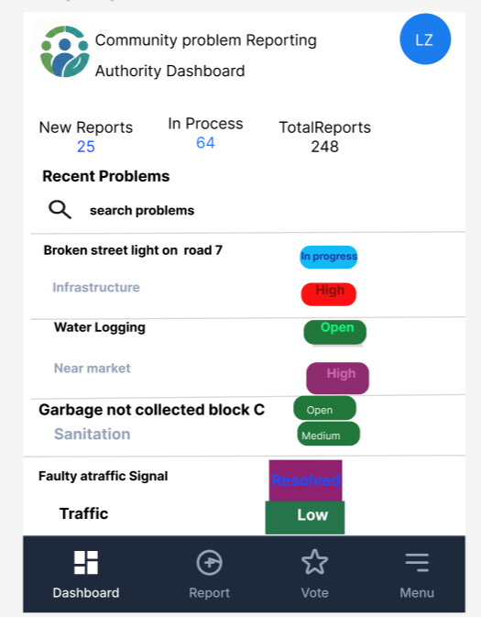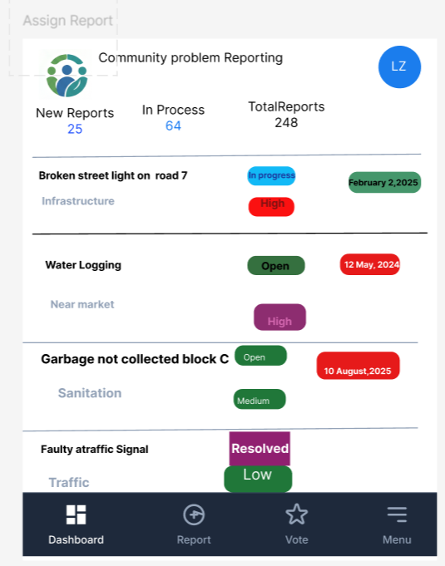
Figure: Authority Dashboard Figure: Assign Report

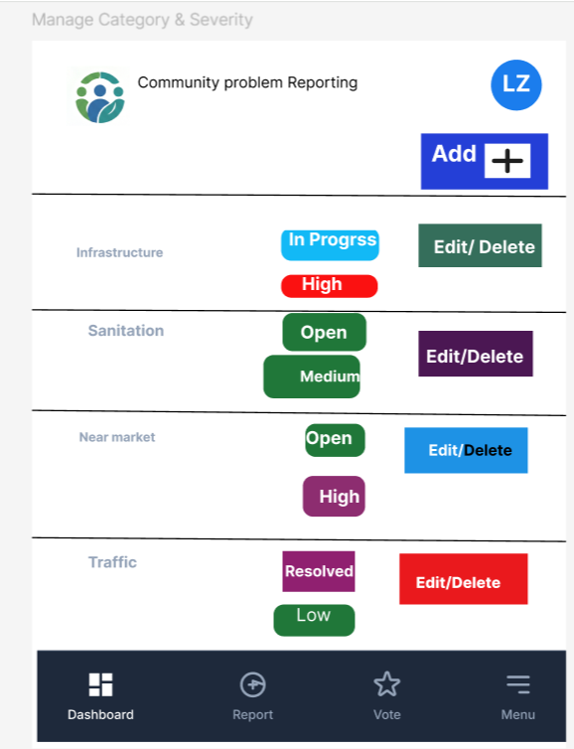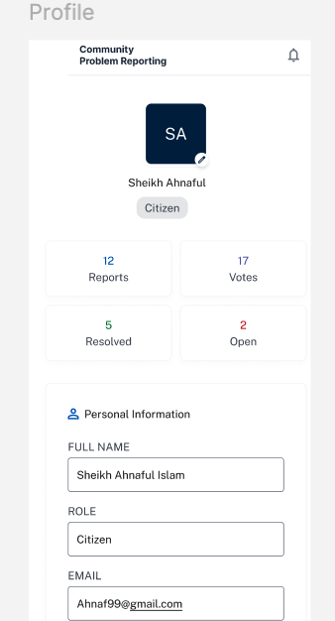

Figure: Manage Category & Severity Figure: Profile

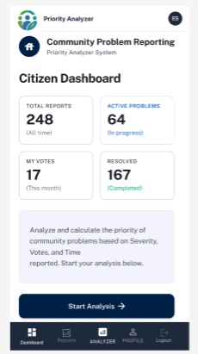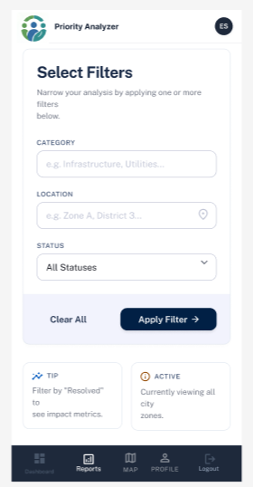
Figure: priority Analyzer ( Start ) Figure: Apply Filters
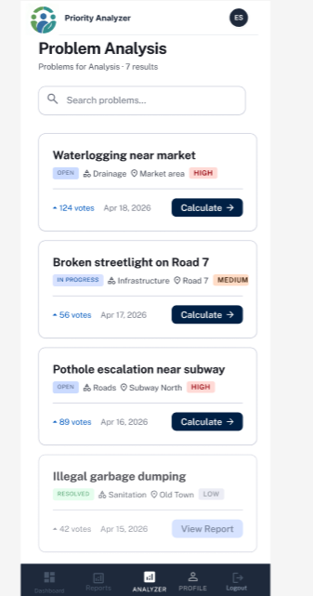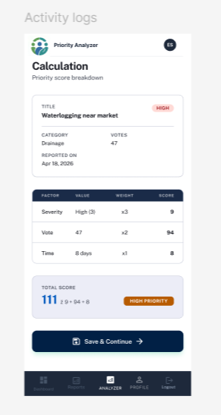
Figure: Problem Analysis Figure: Calculation
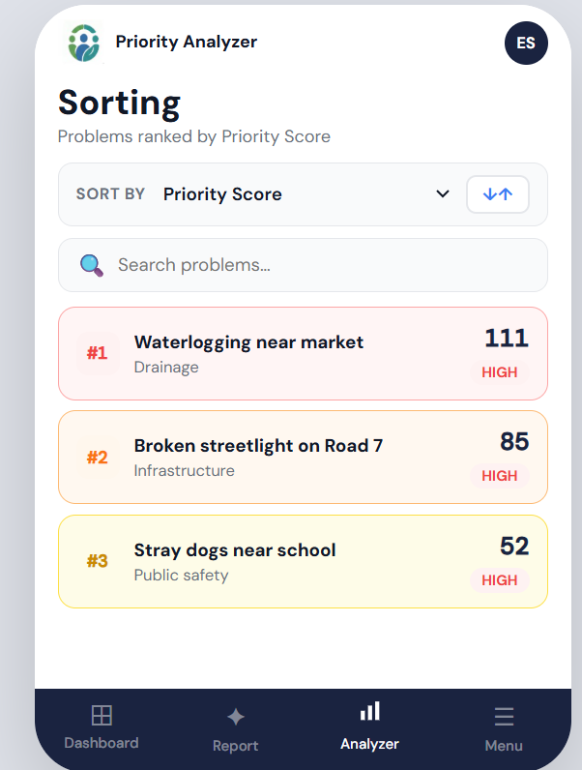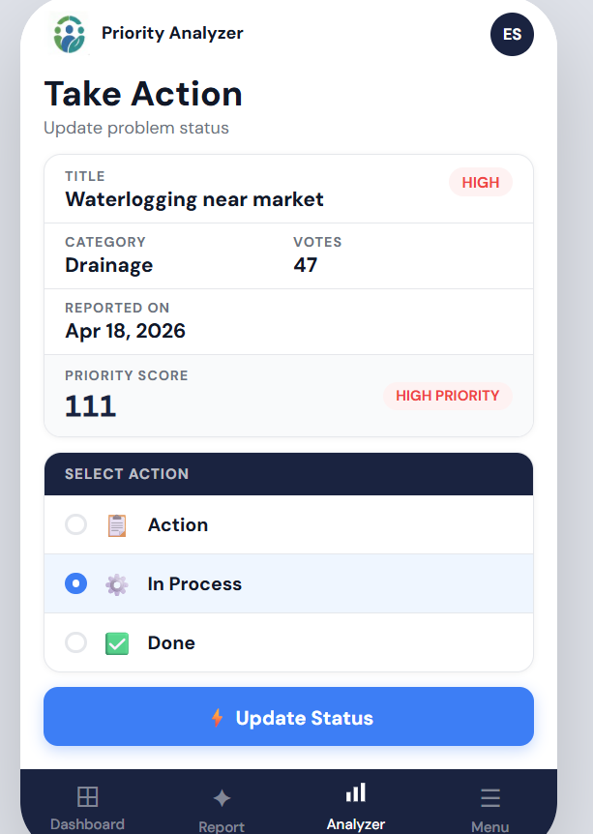
Figure: Sorting Figure: Take Action

